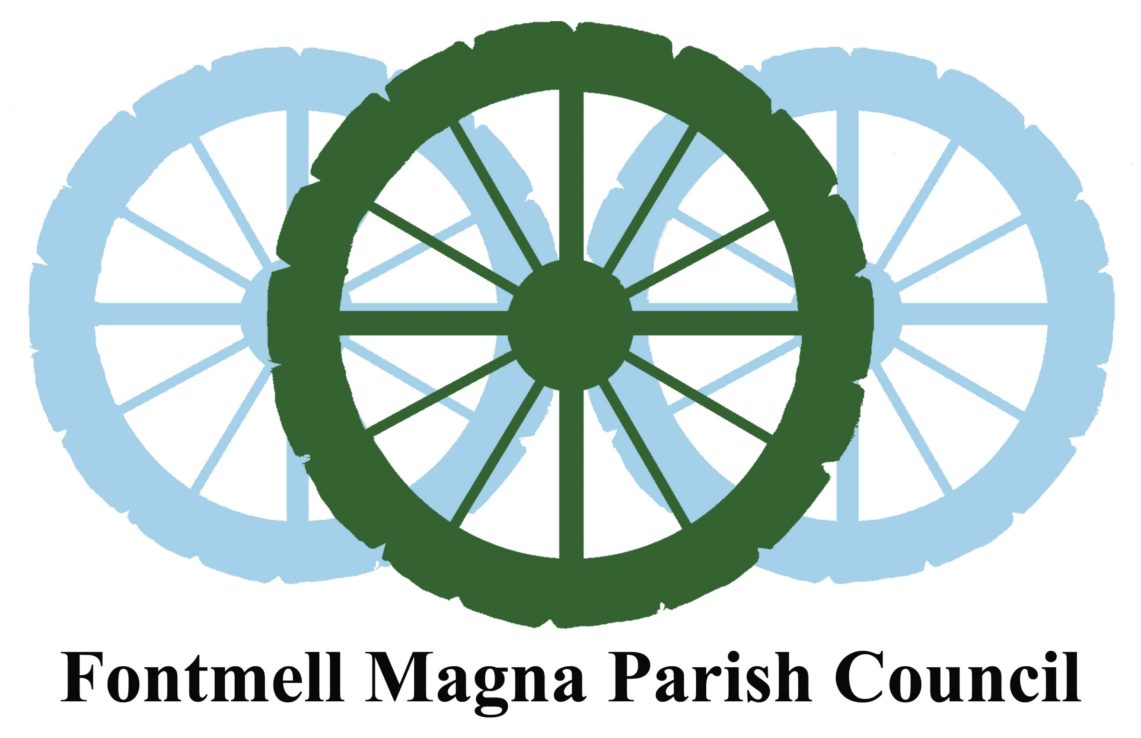

**Fontmell Magna Parish Council**

**NOTICE OF THE MEETING AGM, ANNUAL PARISH & PC MEETING**

**The following Councillors are summoned to attend the Meeting of the**

**Parish Council which will take place at THE VILLAGE HALL, Fontmell Magna**

**on: Tuesday 16Th MAY 2023 at 6.30 pm**

**Cllrs A Davis (Chair), A Main, L Kurton, C Scott, H Lister & L Scott-Walby**

***Tea and Coffee served from 6.00 PM***

**AGENDA**

**AGM (from 6.30 to 7.00**

1. **Welcome and apologies**
2. **Co-opt new PC Councillor and election of Chairman and Vice Chairman 2023-24**
3. **Assignment of Councillor responsibilities**

**ANNUAL PARISH MEETING: (Approx 7.00 TO 7.30)**

1. **Reports from Parish Clubs, Societies and Groups.**
2. **Public Open Forum**
3. **Parish Council Annual Report 2022-23**
4. **Report from Dorset Ward Councillor.  
     
   Parish council meeting (approx. 7.30 to 8.15)**
5. **Declarations of Interest**
6. **Approve the minutes of the PC meeting held on the 18th. April 2023**

**10 Consider any matters arising from the April minutes – (not covered by this agenda)**

10.1 Update of School drop off usage (Hannah)  
10.2 Memorial Garden grass cutting contract – Andrew  
10.3 New defibrillator – confirmation of funding - Christine  
10.4 Plan for defibrillator training – Christine

10.5 Start-up on new VETS emergency response system – Christine

* 1. Completion date for new footpath from school drop off area - Andy

**11 Report from Clerk (Chair)**

11.1 Finance update & resolve to pay bills presented  
11.2 Year-end accounts and plan for audit  
11.3 Approval of the PC Annual Return 2022-2023:

**12 Planning –**

12.1 Planning applications received:

* P/PAAC/2023/00853 - St Andrews Farm Barns. 

12.2 Blandford Farm Barns development – update

13 **Neighbourhood Plan Review Group** – Update from chair of Review Group

**14 Highways**

14.1 Update on 20-mph speed limit application

**15.** **Community Reach**

15.1PC membership to DAPTA Committee

**16. Communications**16.1 Mobile network survey – update  
16.2 New parish information web-site  
  
**17. Governance.**17.1 Update on recruitment of new Clerk

**Dated:** 4th May 2023 Andrew Davis – Chair to the Parish Council

**Date of next meeting:** 20th. June 2023