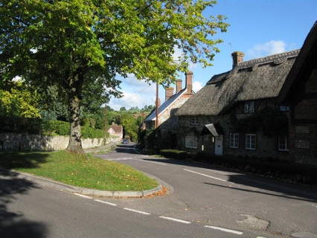
Fontmell Magna Parish Council

Councillor Roles

1. Introduction
In March 2024 the Parish Council reviewed the roles and responsibilities of councillors in respect of issues and activities affecting parish residents. These arrangements were approved and came into force at the May 2024 Parish Council meeting.

2. Area of Responsibility
Areas of responsibility are defined as follows:
- Planning – planning applications, neighbourhood plan updates, Neighbourhood Plan Monitoring Group, planning regulations.
- Highways – road maintenance, signage and potholes, traffic management, speed watch, strategic planning, A350CG.
- Environmental Protection – flood protection, snow clearance, verges, litter and fly tipping, grass cutting, grounds and hedgerow maintenance, dog fouling, applications for tree work and encouraging tree planting, Best Kept Village.
- Community Reach - police, health & medical services (e.g. Patient Partnership Group, Dorset CCG, Shaftesbury Hospital), DAPTC and NALC, Dorset Unitary Council, Climate & Ecological Support group, neighbouring parish councils, Compton Abbas airfield, sources of funding.
- Parish Communications – parish website (including posting of The Gossip Tree), email group, social media, village shop liaison, parish notice boards, Annual Parish Report.
- Social Infrastructure – maintenance of parish council assets, Home Watch, defibrillators, village shop, broadband and mobile coverage, recreation, allotments, Village Hall.
- Footpaths and Rights of Way.
- Governance – procedures, new councillor recruitment and induction, councillor training, committees, risk management, contingency planning.

These broadly matched the division of responsibilities operating in adjacent parish councils.

3. Councillor Roles
Each parish councillor would elect to take a specific area of responsibility to cover. The councillor would be expected to be the lead on any issue arising within their remit, and would involve other councillors or the Clerk or third parties as needed to take action to resolve an issue.

The PC meeting agenda has been restructured to provide for reporting on these responsibilities. The appropriate councillor is expected to give a short report on matters arising in their respective areas at each Parish Council meeting, even if it is “nothing to report”.

4. Current Allocations
At present the Parish Council is operating with a full complement of seven councillors.
The allocation of responsibilities is as follows:

 | Area | Responsibilities | Who
1. | Planning | Planning applications, NP Monitoring Group, planning regulations. | Laura SW
2. | Highways | Road maintenance, signage and potholes, traffic management, speed watch, strategic planning, A350CG. | John Robert-Davies
3. | Environmental Protection | Flood protection, snow clearance, verges, litter and fly tipping, grass cutting, grounds and hedgerow maintenance, dog fouling, applications for tree work and encouraging tree planting, Best Kept Village. | Christine Scott
4. | Community Reach | Police, health & medical services (e.g. Patient Partnership Group, Dorset CCG, Shaftesbury Hospital), DAPTC, Dorset Unitary Council, Climate & Ecological Support Group, neighbouring parish councils, Compton Abbas airfield, sources of funding. | Hannah Lister
5. | Parish Communications | Parish website (including posting of The Gossip Tree), email group, social media, village shop liaison, parish notice boards, Annual Parish Report. | Laura Kurton
6. | Social Infrastructure | Maintenance of parish council assets, Home Watch, defibrillators, village shop, broadband and mobile coverage, recreation, allotments, Village Hall. | Jeremy Long
7. | Footpaths | Footpaths, rights of way, signposts. | Andy Main
8. | Governance | Procedures, standing orders, regulations, new councillor recruitment and induction, councillor training, committees, risk management, contingency planning. | Clerk, Chair, Laura SW

The allocation of responsibilities will be reviewed from time to time and adjusted as new councillors are recruited.

Hannah Lister
Chair
April 2024

